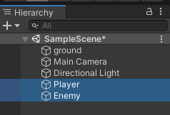Tutorial 2: Enemy chase player

1. Firstly, you must have two objects (can be anything) to act as your player and enemy. 🡪 the player must have a simple movement script attached to it. So, the player can move around the scene, but the enemy is static.

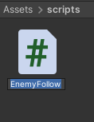

1. Now make a brand-new C# script called ‘Enemy Follow’ and open it up.
2. 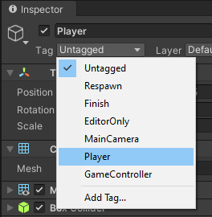make two variables; one public of type float called speed and another private variable of type transform called targets. Then in the start function type in this code:
3. 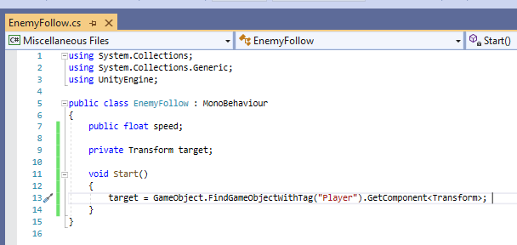BUT make sure your player has the tag Player.
4. 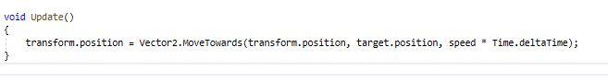Lastly, make an update function in the script and type this code:
5. Add this script to the enemy in the inspector and change the speed variable to 10.
6. 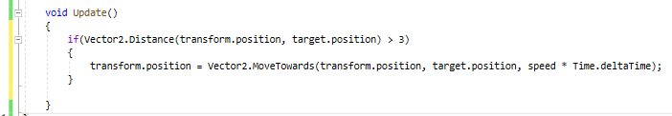The enemy will follow the player when the play button is pressed. A problem that will occur is that the enemy is going in the exact position of the player and cover it up. To stop the enemy moving towards the player at a certain distance, we must add an If statement:
7. If you want more flexibility on where the enemy stops chasing the player – just make a public float variable called stopping distance:

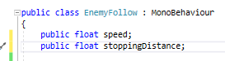You can then change it in the inspector where the script is to decide how far away you want your enemy to stop